Given the following tables: **trn_teacher**

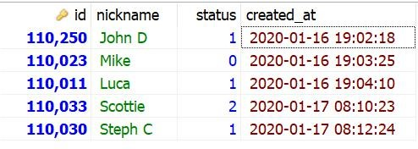

(note: status 0=discontinued, 1=active, 2=deactivated)

**trn_teacher_role**

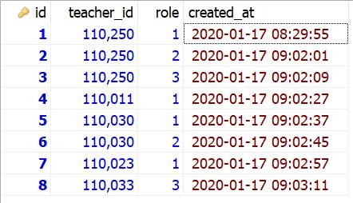

(note: role 1=trainer, 2=assessor, 3=staff)

**trn_time_table**

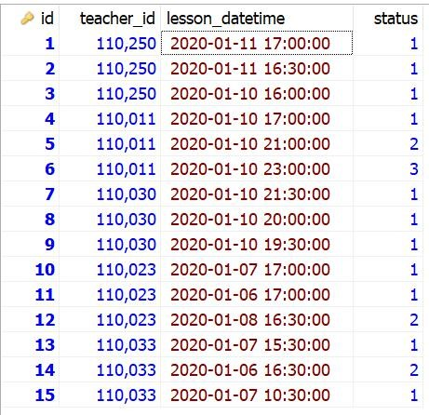

(note: status 1=open, 2=backup, 3=reserved)

**trn_evaluation**

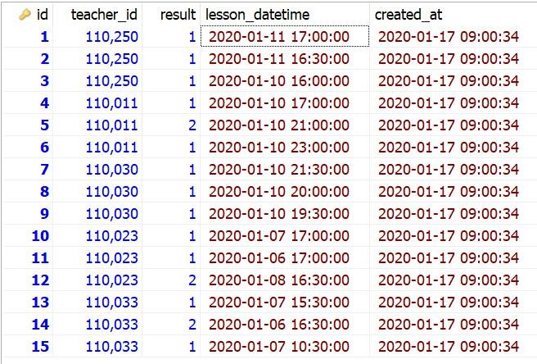

(note: result 1=taught, 2=noshow)

1. Write a query to display the ff columns ID (should start with T + 11 digits of trn_teacher.id with leading zeros like

'T00000088424'), Nickname, Status and Roles (like Trainer/Assessor/Staff) using table trn_teacher and trn_teacher_role.

*Sample output:*

|  |  |  |  |
| --- | --- | --- | --- |
| *ID* | *Nickname* | *Status* | *Roles* |
| *T00000110019* | *Jake* | *Active* | *Trainer/Assessor* |

**Answer:**

**SELECT**

**CONCAT("T",RIGHT(CONCAT('0000000000', trn_teacher.id),11)) as ID,**

**trn_teacher.Nickname,**

**CASE trn_teacher.status**

**WHEN 0 THEN 'Discontinued'**

**WHEN 1 THEN 'Active'**

**WHEN 2 THEN 'Deactivated'**

**ELSE '--'**

**END as Status,**

**GROUP_CONCAT(**

**CASE trn_teacher_role.role**

**WHEN 1 THEN 'Trainer'**

**WHEN 2 THEN 'Assessor'**

**WHEN 3 THEN 'Staff'**

**ELSE '--'**

**END SEPARATOR '/') as Roles**

**FROM trn_teacher**

**LEFT JOIN trn_teacher_role on trn_teacher_role.teacher_id = trn_teacher.id**

**GROUP BY trn_teacher_id**

***2.****Write a query to display the ff columns ID(from teacher.id),*

*Nickname, Open(total open slotsfrom trn_teacher_time_table),*

*Reserved (totalreservedslotsfromtrn_teacher_time_table), Taught (totaltaughtfromtrn_evaluation)andNoShow(total no_show from trn_evaluation) using all tables above. Should show only those who are active (trn_teacher.status = 1 or 2) and those who have both Trainer and Assessor role.*

*Sample output:*

|  |  |  |  |  |  |
| --- | --- | --- | --- | --- | --- |
| *ID* | *Nickname* | *Open* | *Reserved* | *Taught* | *No Show* |
| *110019* | *Jake* | *2* | *1* | *1* | *1* |

**Answer:**

**SELECT**

**trt.ID,**

**trt.Nickname,**

**(SELECT SUM(IF(status = 1, 1, 0)) FROM trn_time_table WHERE teacher_id = trt.id) AS 'Open',**

**(SELECT SUM(IF(status = 3, 1, 0)) FROM trn_time_table WHERE teacher_id = trt.id) AS 'Reserved',**

**(SELECT SUM(IF(result = 1, 1, 0)) FROM trn_evaluation WHERE teacher_id = trt.id) AS 'Taught',**

**(SELECT SUM(IF(result = 2, 1, 0)) FROM trn_evaluation WHERE teacher_id = trt.id) AS 'No Show'**

**FROM trn_teacher trt**

**LEFT JOIN trn_teacher_role trtr on trtr.teacher_id = trt.id**

**WHERE**

**trt.status in (1, 2)**

**AND**

**trtr.role in (1, 2)**

**GROUP BY trt.id**

**HAVING**

**COUNT(DISTINCT trtr.role) = 2**